I used Orange3 to build a Neural Network model to predict the presence of heart disease using the heart_disease.tab dataset. I connected the File widget to Select Columns, where I set diameter narrowing as the target variable. Afterward, I connected it to a Neural Network learner and then to the Test & Score widget. I made sure to use **random sampling** with a **70/30 train-test split**, and then visualized the results using a **Confusion Matrix**.

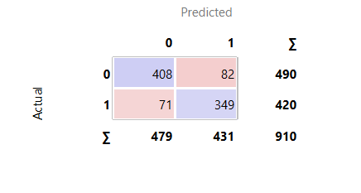

From the confusion matrix, I noticed that:

* **408** healthy individuals were correctly identified (true negatives),
* **349** individuals with heart disease were correctly predicted (true positives),
* **82** healthy individuals were misclassified as having heart disease (false positives), and
* **71** individuals with heart disease were misclassified as healthy (false negatives).

The model correctly classified **757 out of 910 cases**, which I consider a fairly strong performance. However, I am concerned about the 71 false negatives. In a real-world medical setting, this could mean that people who have heart disease are not flagged for further testing or treatment, which could lead to serious health consequences. On the other hand, the 82 false positives, while less critical, could still lead to unnecessary anxiety or medical procedures for patients who are healthy.

To enhance the model, I would explore various options, such as experimenting with the number of hidden layers or neurons in the neural network. Additionally, I would consider increasing the number of training epochs and comparing the results with other models, like Random Forest or Logistic Regression. Implementing feature selection or normalization could also help improve the learning process. Overall, I found that the neural network performed well on the classification task, but there is still room for improvement, particularly in reducing the number of false negatives.